**Download Anaconda**

<https://www.anaconda.com/products/distribution>

**Open Spyder:**

**Code for all files (3 steps)(All the results):**

**This code can process all the files in the working directory, Keywords are not need.**

**1.upload the code file (VRE Code for all.py)**

**2. change the Pathway where you store the resource files.**

**3. press the run button**

**Code for keywords search (4steps)(only single result)(Case sensitive) :**

**1. Upload the code file: Keywords search for single.py**

**2. Change the Pathway where you store the resource files.**

**3. Type the keywords (1-3) you want to locate the files. If you only need one or two keywords, just keep other names null. (see below picture)**

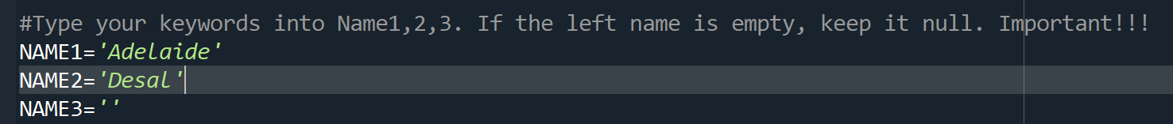

**4. press the run button**

